**SAP BW/BO Exercise**

**Exercise 3: Using SAP Business Objects Analysis**

**SAP ERP Login Id:**

**Note: You must use the following conventions to name objects/systems created in this exercise.**

**Replace S with A - for Fall semester**

**B - for Spring semester**

**C - for Summer semester**

**Replace YY with the last 2 digits of the current year.**

**Replace XXX with your SAP ID.**

**Objectives:**

The purpose of this exercise is to use a predefined query on SAP BW data within *SAP Business Objects Analysis for Microsoft Excel*. You will analyze these data using multi-dimensional reporting techniques. A number of basic multi-dimensional navigational techniques will be introduced.

**SAP BusinessObjects Analysis:** OLAP Analysis Tool used to manipulate information by utilizing data targets (infocubes & DSO) in SAP BW.

**Exercise Name**

In this exercise, you will build some more navigation skills in SAP BusinessObjects Analysis in addition to the ones you learned and used in the previous exercises.

**PART 1**

1. Instead of starting plain Excel, start the Excel Add On SAP BO Analysis for Microsoft Excel. The Excel Ribbon now contains an additional Tab Analysis (1).

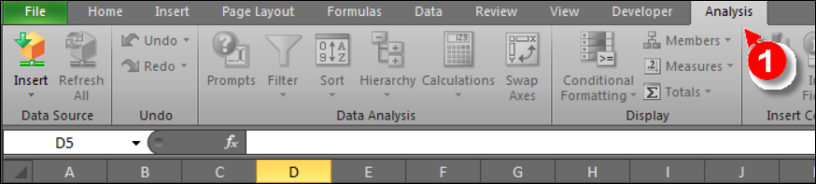

1. Click on Insert to insert a new data source.

Note: The system may ask you to enter the credentials again.

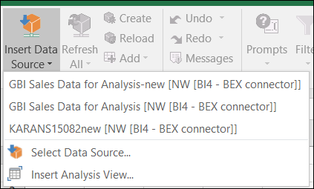

1. On the next screen choose Skip:

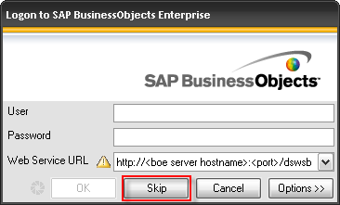

1. Select BI4 – BEX Connecter and click on Next

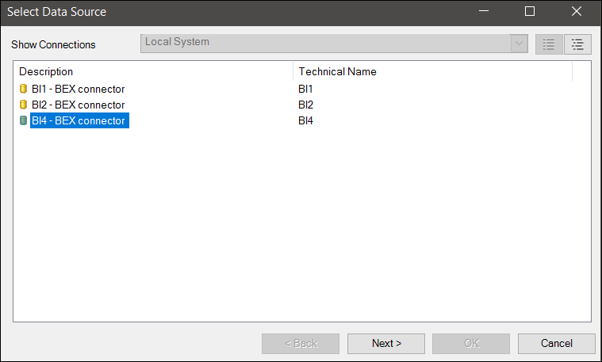

1. Enter your assigned SAP login credentials and click ok.

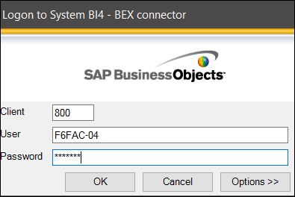

1. Go to search and type MU0R1M_Q1NEW. Click on .

A connection to the SAP BW system is established and the data is read from the InfoCube. The structure of the screen is similar to Pivot Tables. The cross tab on the left and the list of dimensions and measures on the right side.

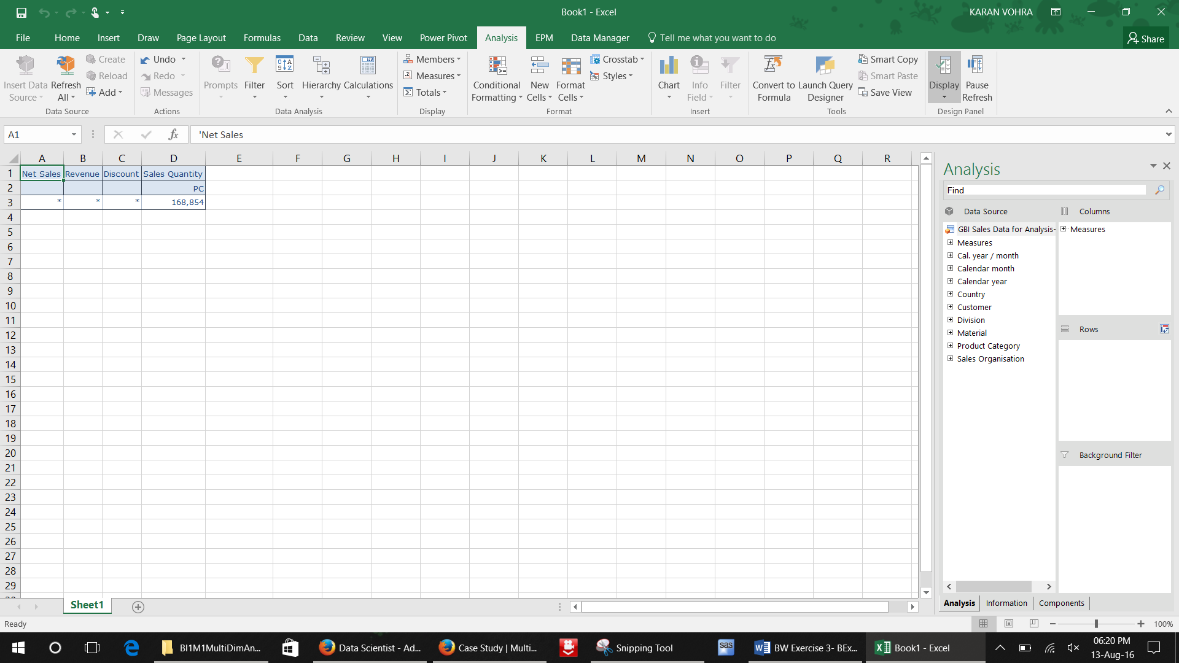

**Paste a screenshot of the query.**

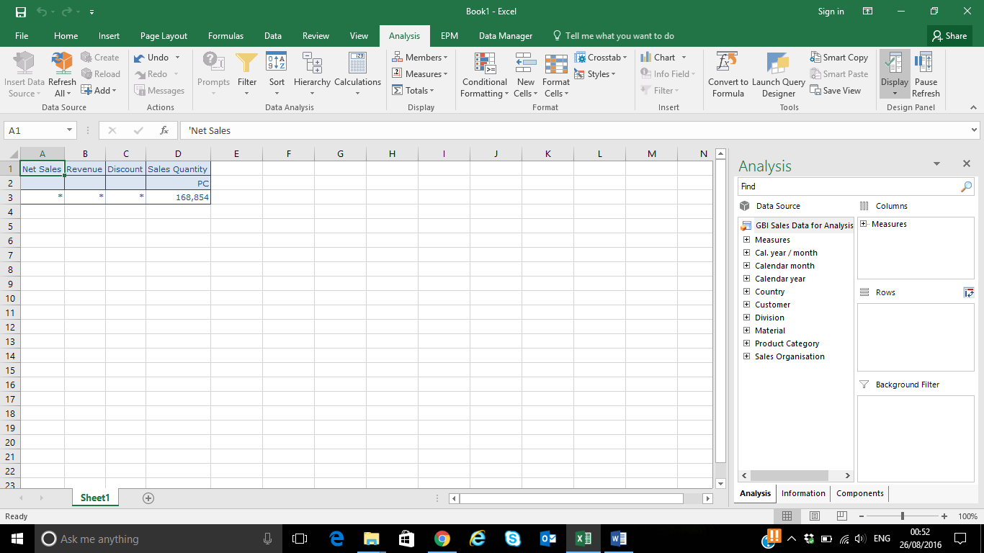

1. In Columns tab, right click on Measures and select Filter By Members. Drag Country and Calendar Year from Data Source to Columns and Rows respectively.

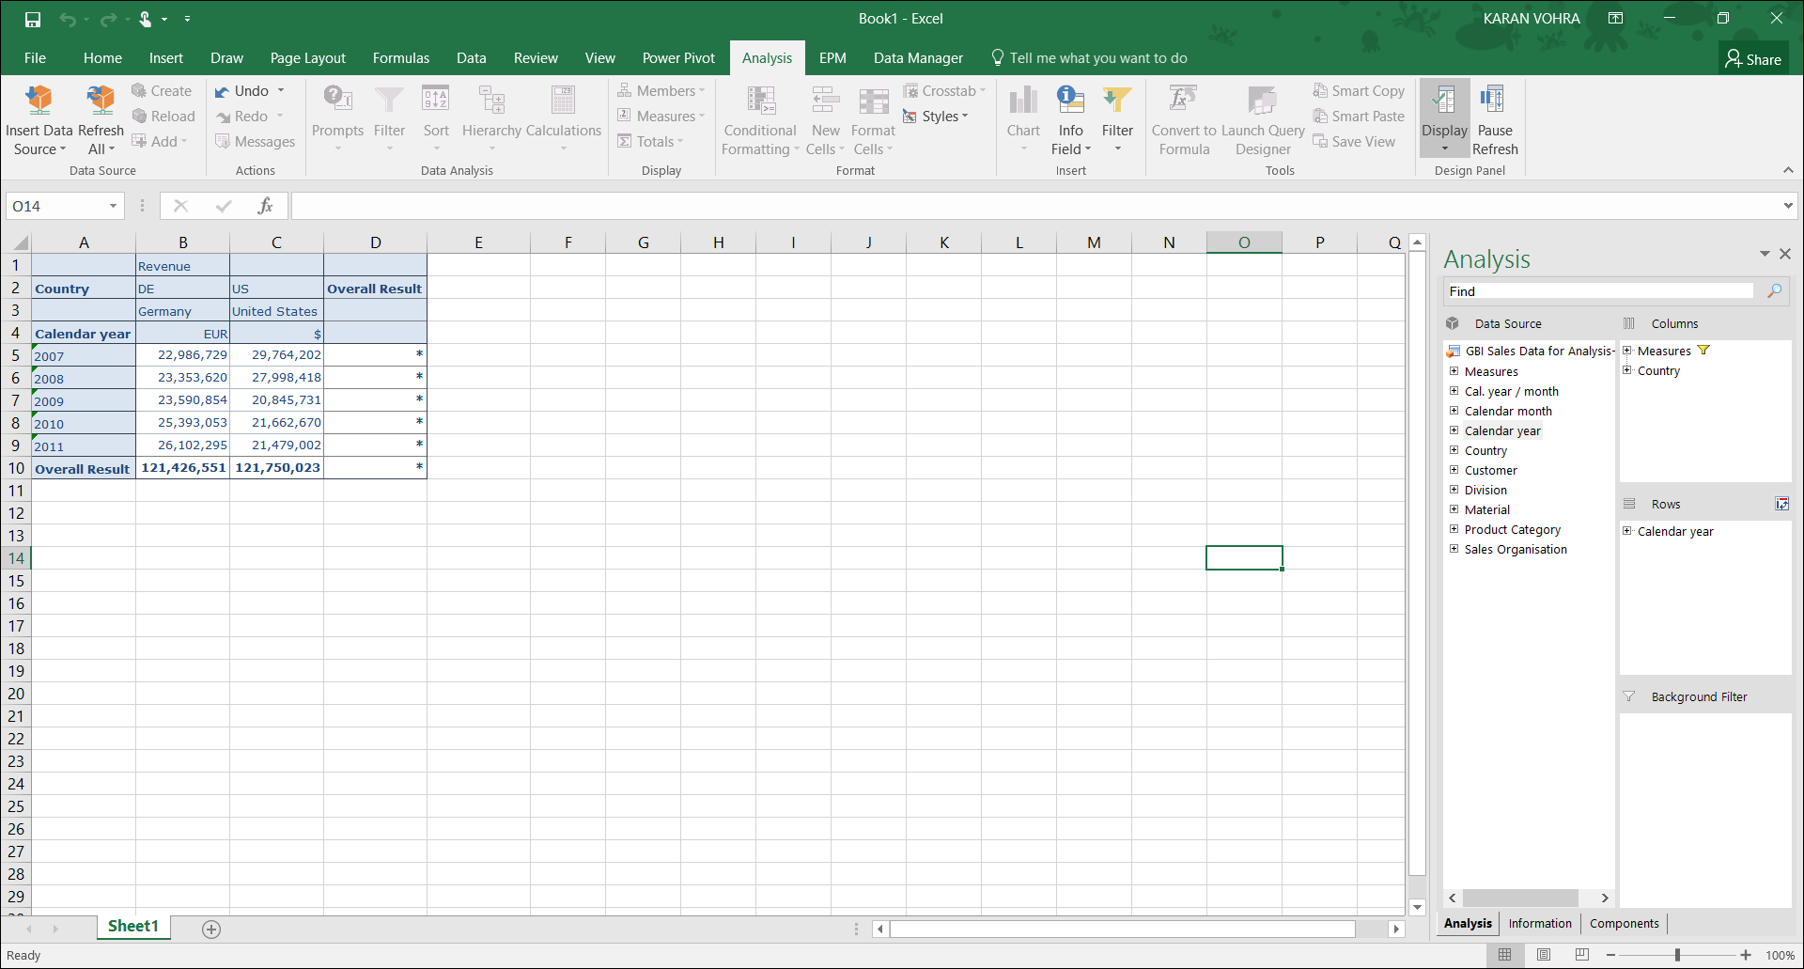

**Why is the Overall Results column filled with asterisks (*)?**

**Answer: The Overall Results column is addition of two different currencies i.e. Net Sales of Germany (currency Euro) and Net Sales of United States (currency $). The currency for column “Overall Result” is not defined and due to this the column is filled with asterisks (*).**

1. Change the view by showing only the texts of the countries: Right click on Country, go to Members and select Text. Exchange Country and Calendar Year, put Country in the rows and Calendar Year in the columns.

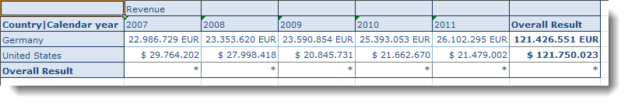

You can observe a different behavior in two countries: Germany shows a continuous increase in revenue and there is a sharp decline in the US in 2009. We would try to identify reasons for this behavior in the data. We will do this by slicing the data.

1. We analyze the data from Germany first by doing a slice on country. Right click on Germany and select Filter Members.

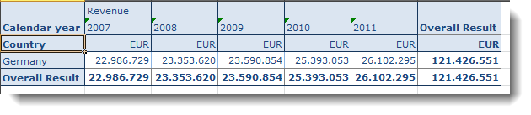

**Paste a screenshot of your query after slicing it by country(Germany).**

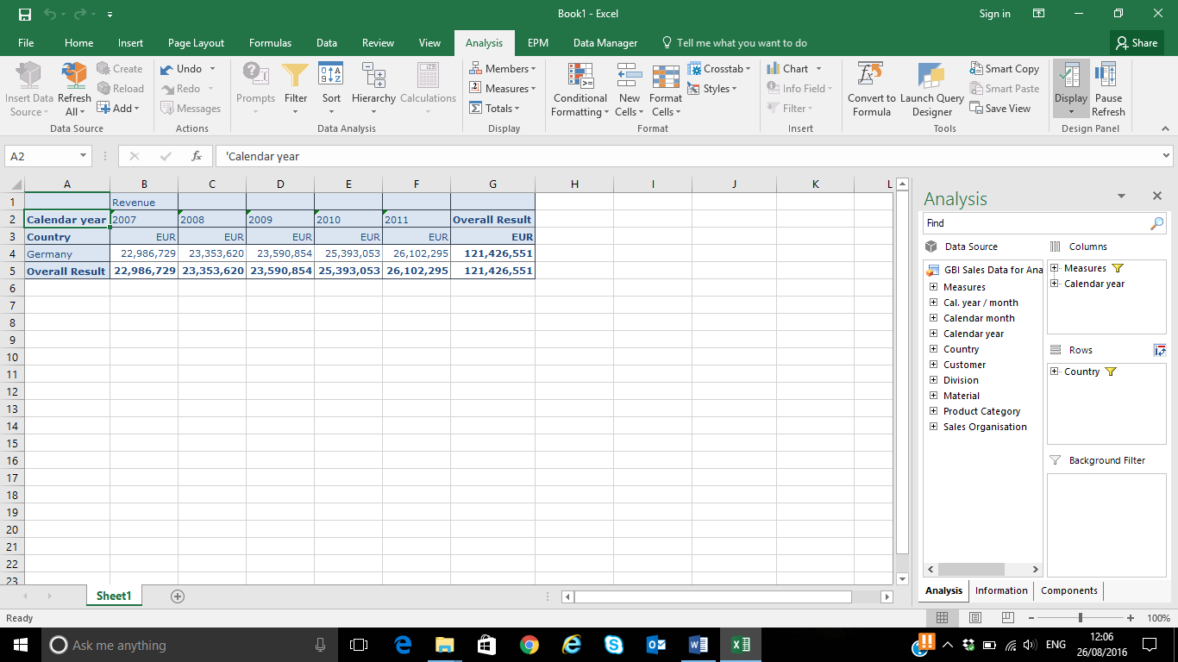

1. As a next step, drill down to the Sales Organization. Move the Country from Rows to background filters and Sales Organization from Data Source to Rows. There is no dependency visible: both Sales Organizations behave similarly.

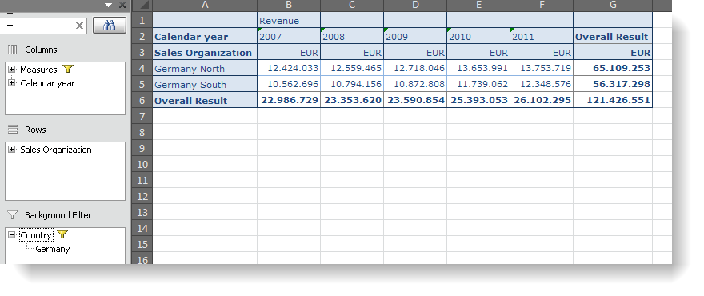**Paste a screenshot of your query after slicing it by Sales Organization.**

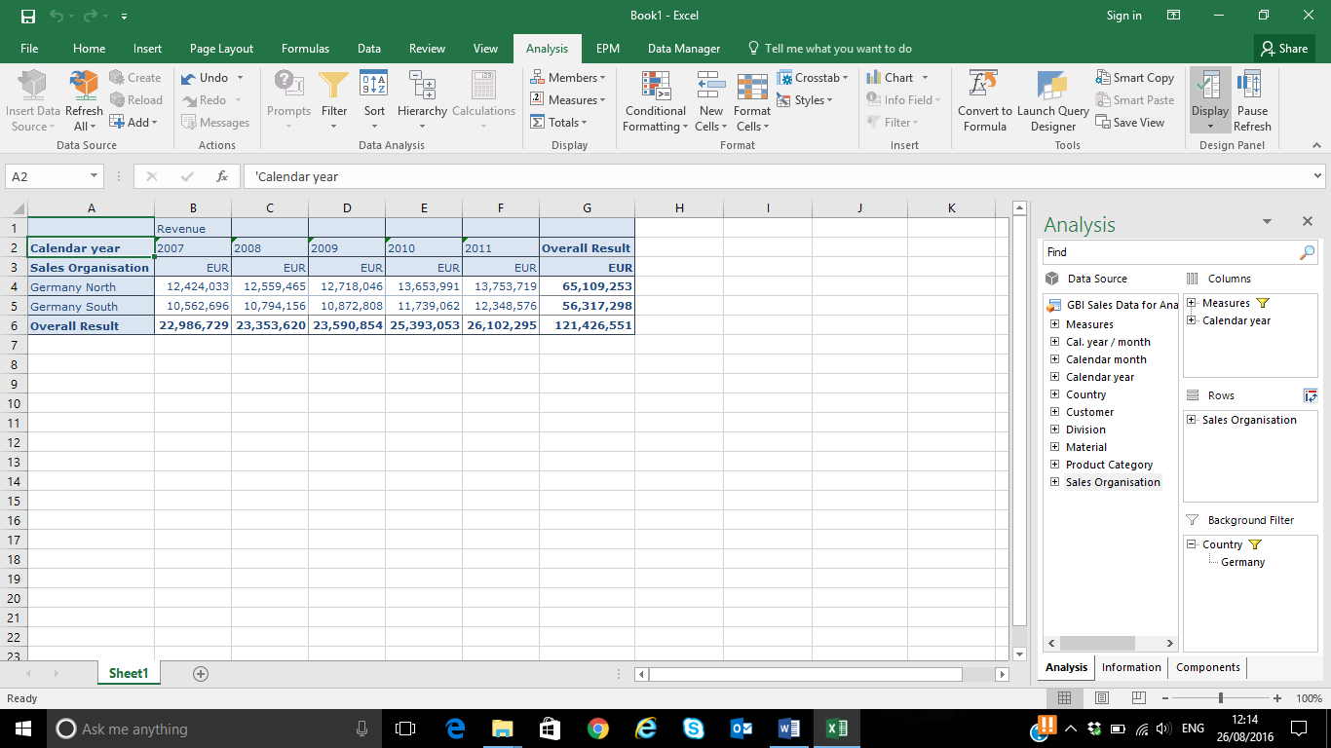

1. From the Sales Organization, drill down to Customer. In rows, swap Sales Organization with Customers.

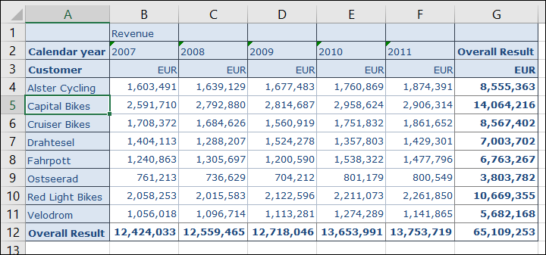

**Paste a screenshot of your query after swapping Sales Organization with Customers.**

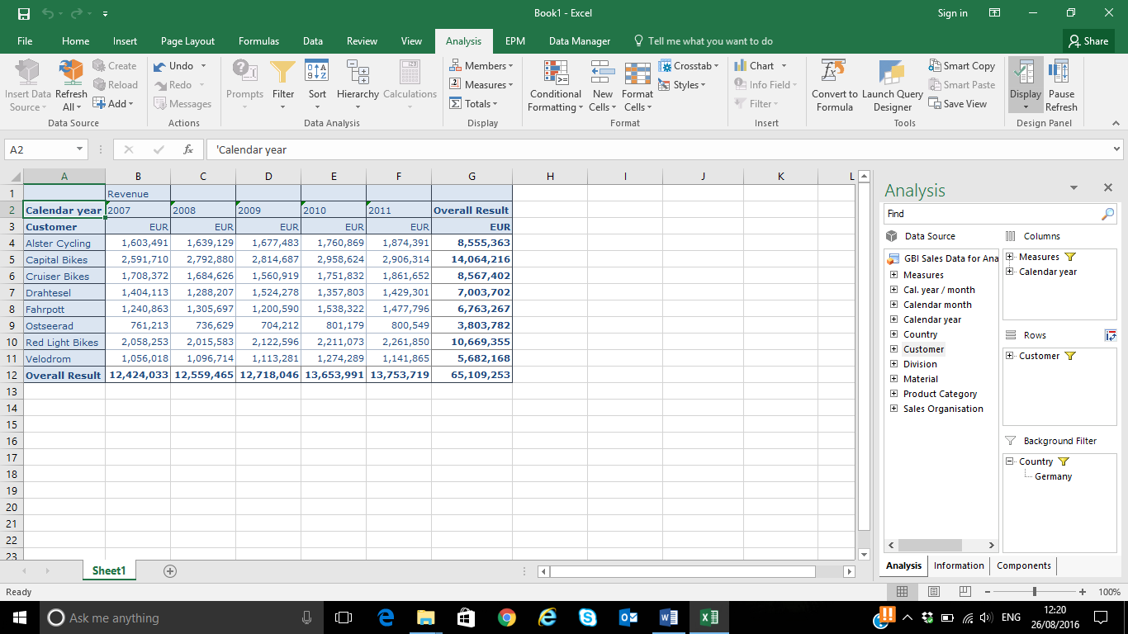

1. Check the dependency on Product Category and Material by rotating the cube and a subsequent drill down. In rows, swap Customers with Product Category and Materials.

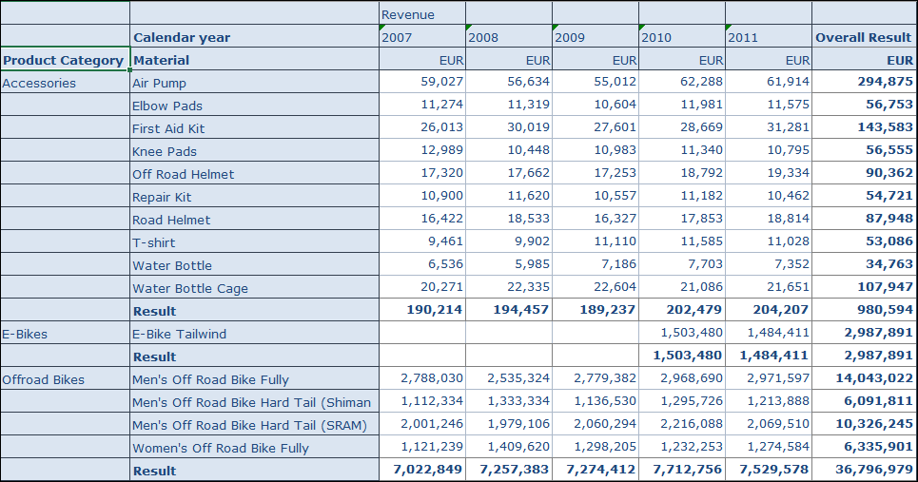

1. Choose a compact display as a hierarchy in the rows.

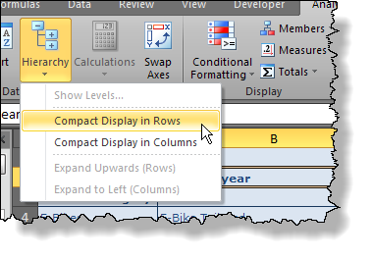

Your query should look something like this:

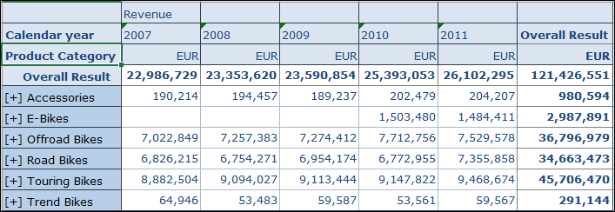

**Paste a screenshot of your query after switching on Compact Display for Rows.**

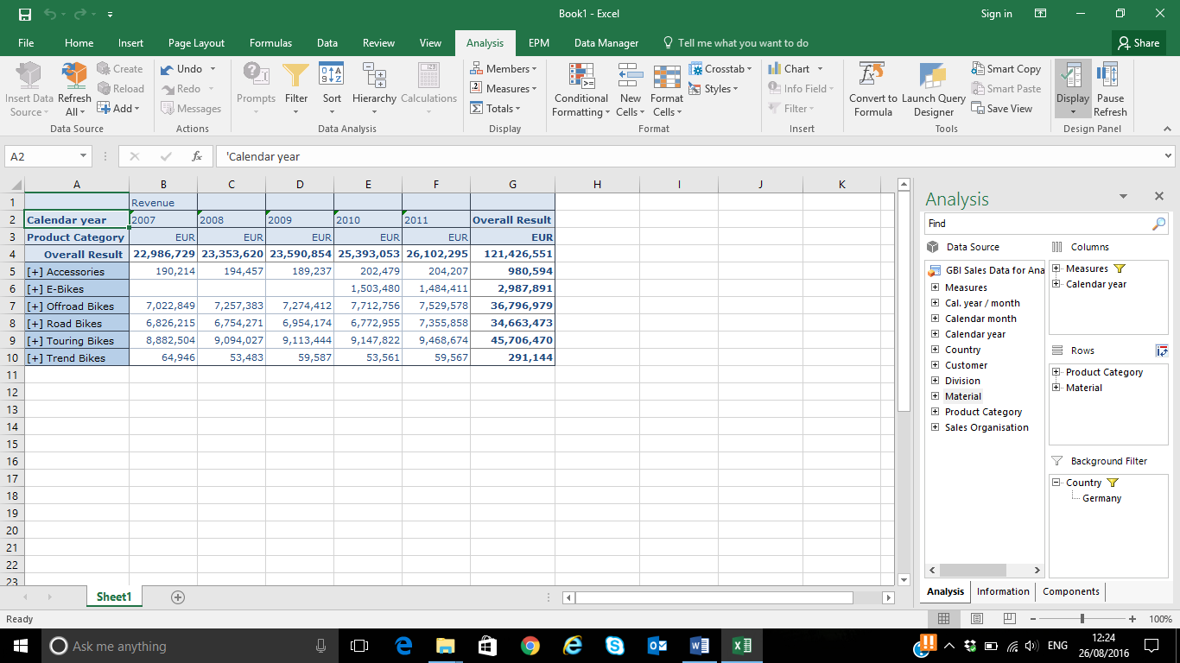

We observe the introduction of a new product in 2010: the new E-bike Tailwind. Now, we will analyze this new market in more details.

**PART 2**

1. We will compare the new E-Bikes with other bikes and filter the last two years on all bikes. In the table, select 2010 and 2011 after right clicking select Filter Members. We will switch off the hierarchical display mode as well. Drag Division from Data Source to Background Filters and select BI(Bicycles). Instead of showing the revenue in absolute numbers, we will add a dynamic calculation Percentage Contribution to the revenue. In the table, select Revenue, right click on it and select Add Dynamic Calculation->Percentage Contribution. In Rows, remove Product Category and sort the data by revenue.

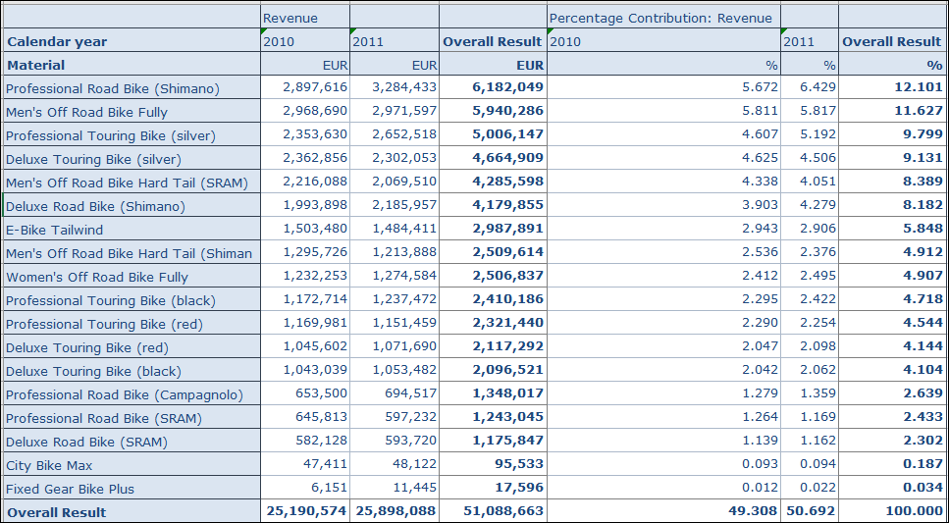

We recognize that the new product already contributes more than 5% to the total revenue.

1. Finally, we will perform a drill down to calendar month to see the successful product introduction in 2010. Drag Cal. year/month from data source to Columns and remove Revenue from columns.

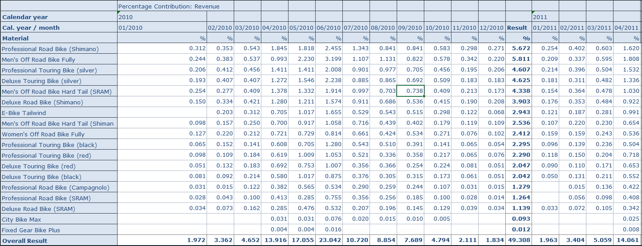

**Paste a screenshot of your query after performing a drill down calendar month.**

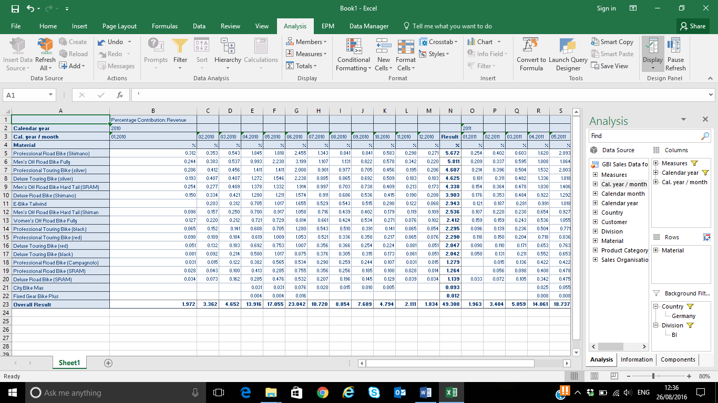

**PART 3**

**Analyzing the US Data**

1. Now, we analyze the situation in the US. Remember that we observed a sharp revenue decline between 2008 and 2009 and we want to find out reasons for this. Therefore, insert a second crosstab into your worksheet and slice the data by country. Exchange country with customer in the rows. Sort the customers by revenue and display the attribute location. We observe that a very important customer is lost between 2010 and 2011.

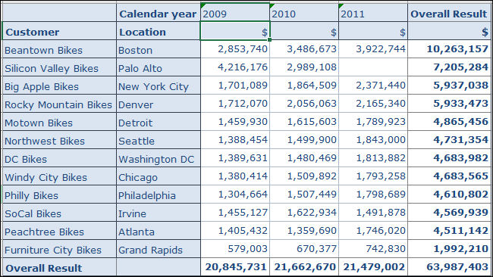

**Paste a screenshot of your query after analyzing the US data.**

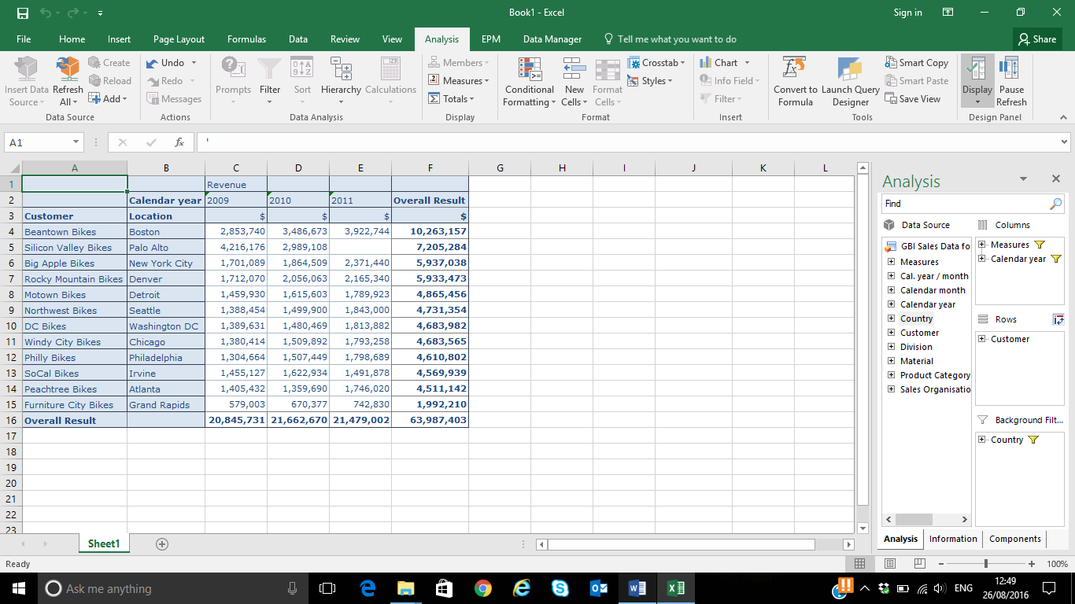

**Question) Which Customer was lost between 2010 and 2011?**

**Answer: The customer “Silicon Valley Bikes” from Palo Alto was lost between 2010 and 2011.**

1. We want to explore this in more detail and use a chart to visualize the data. Filter Silicon Valley Bikes and Beantown Bikes Boston and years 2009 to 2011. Drill down to calendar month and insert a line chart:

Note: Swap axis after creating a line chart.

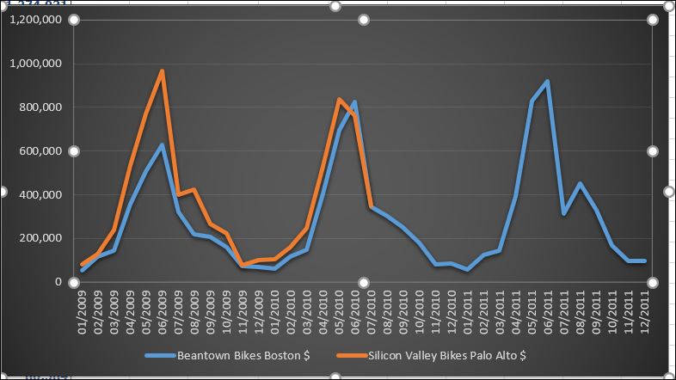

Paste a screenshot of your line chart.

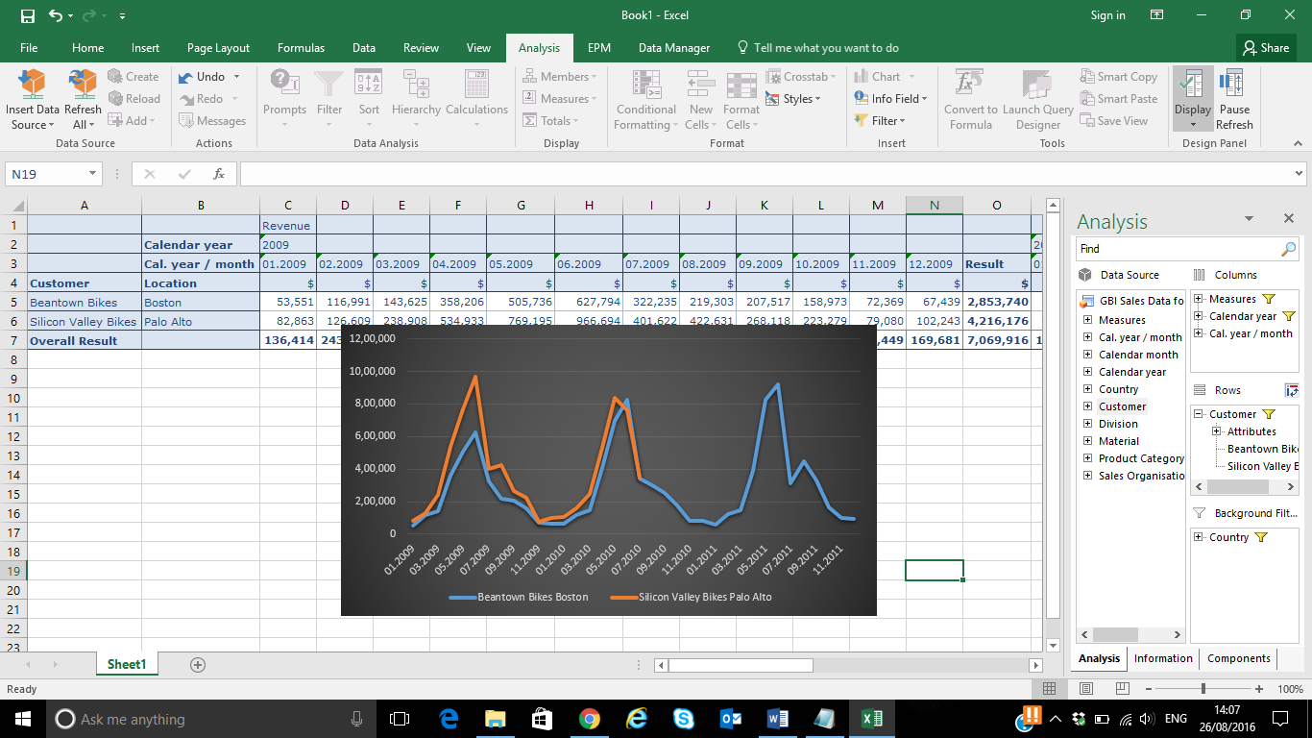

1. We observe that revenue of Silicon Valley Bikes is zero from August 2010 on. We have to ask the responsible sales person what was going on here. In order to detect other effects, we exclude this customer from the subsequent steps. Also, remove the filter on the calendar year.

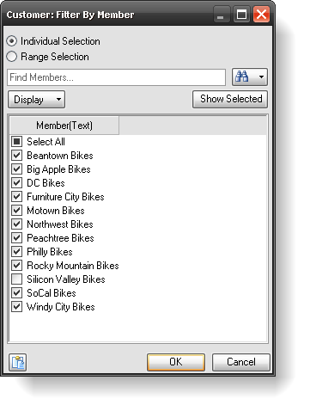

1. Check whether the decline in the US revenue is specific for the sales organization or product categories. In other words: remove the drill down by calendar month first, add a drill down by product category.

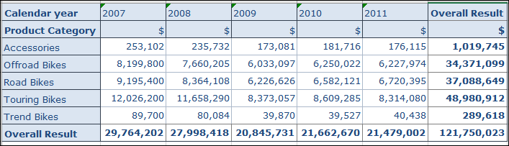

Then rotate the cube by exchanging product category with sales organization.

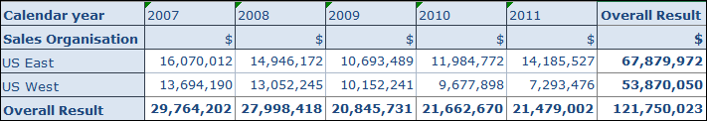

**Question) Is there any dependency visible?**

**Answer: Yes. The Sales Organisation is dependent upon the Product Category. The Overall Result is same for both Sales Organisation and Product Category. The annual overall result is same for Product Category and Sales Organisation which shows the dependency.**

1. Use a bar chart to visualize the detailed timeline for years 2008 to 2010:

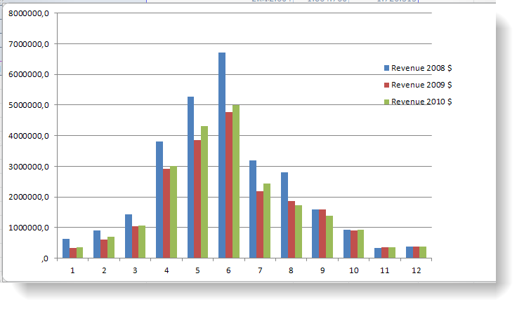

**Paste a screenshot of your bar-chart.**

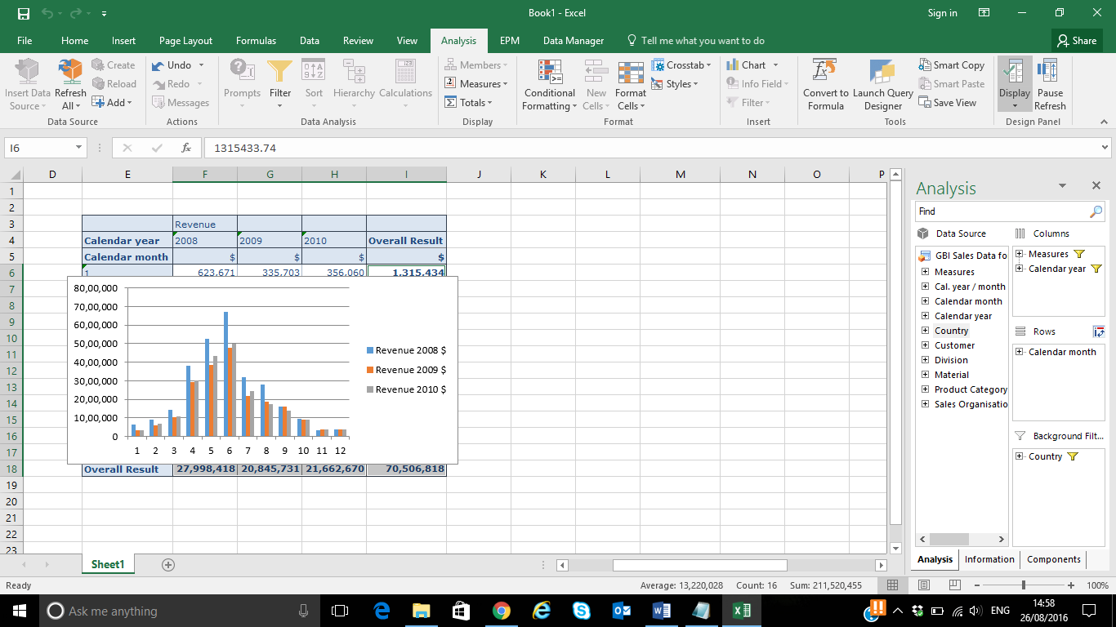

As a matter of fact, we can see the effect of the Lehman crash in September 2008.